Group Exercise 3 – Krummbach
Link to GitHub: https://github.com/Serafina546/PythonProject4
The main Python codes can be found in the directory "Krummbach_model".

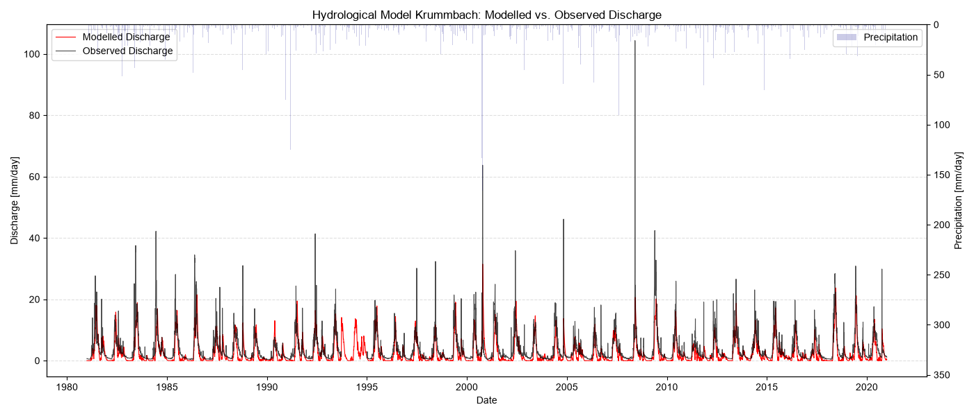
Figure 1: Long-term time series (1981-2020) of modelled discharge (red) versus observed discharge (black) for the Krummbach catchment, with inverted daily precipitation shown on the top secondary axis.

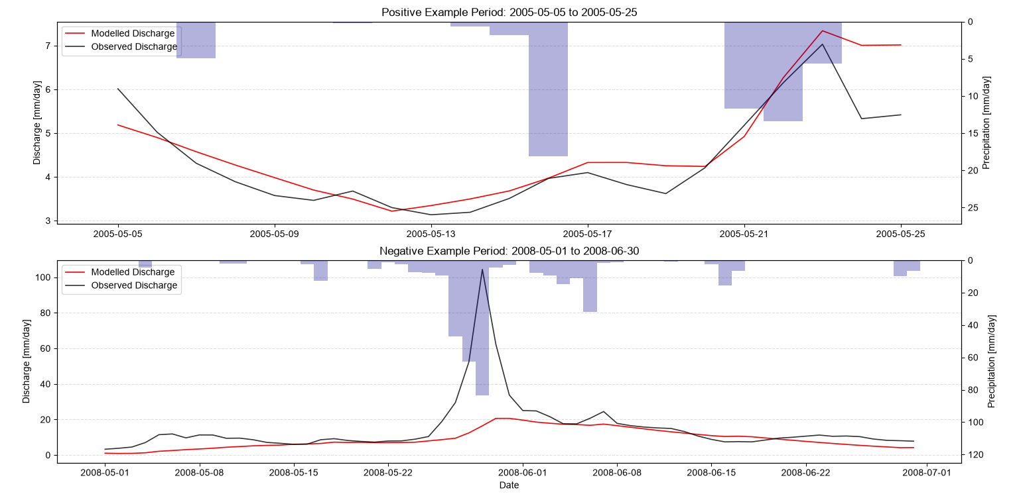
Figure 2: Detailed comparison of modelled versus observed discharge during a positive simulation period (May 2005, top) and a negative simulation period (May-June 2008, bottom). Inverted precipitation is displayed on the top axis.

The lumped hydrological model successfully captures the general seasonal dynamics of the high-elevation, almost treeless Krummbach catchment over the 1981-2020 period (Figure 1). However, several limitations and modelling difficulties become evident when analysing both the long-term overview and the detailed event plots (Figure 2):
As seen in the negative example period (Figure 2, bottom), the model severely underestimates extreme peak discharges during heavy precipitation events. This might be a structural limitation of the single linear reservoir (flowerpot model).
During the selected positive period (Figure 2, top), model performs well by accurately capturing the overall timing and gradual progression of the discharge. Without the interference of extreme weather events of sudden flood peaks, the simulated discharge (red line) closely mirrors the observed data (black line).
In alpine environments, snow is a dominant storage term. The simple degree-day snow model tends to trigger snowmelt or spring responses with slight temporal offsets. Furthermore, due to the linear storage draining behavior, simulated discharges occasionally drop entirely to zero, failing to account for sustained sub-surface baseflow from deep groundwater or remaining snowpacks.
Because Krummbach is an alpine, nearly treeless catchment, standard interception thresholds can cause excessive artificial evaporation. Setting a low interception capacity was necessary to prevent the model from erroneously holding back effective precipitation.
Despite these constraints, the modular Python framework provides a solid foundation.

